**From Union township parks & recreation board:**

**2025 UPCOMING EVENTS \***

**JOIN OUR MAILING LIST TO RECEIVE UPDATED INFORMATION ON THE FOLLOWING FREE EVENTS HOSTED BY UNION TOWNSHIP PARKS & RECREATION BOARD**

**All events will be at the Meadows, 100 Campbellford Road, Douglassville, PA 19518.**

1. ***Easter Egg Hunt*. Celebrate Easter with your Township’s Park & Recreation Board April 12th (Rain Date April 13th) with a candy and toy filled egg hunt. There will be 2 separate hunts - ages up to 6 and a 2nd hunt for ages 6-10. The Easter Bunny will be stopping by! Enjoy pictures and a little treat from the bunny! This event will start promptly at 1:00 pm.**
2. ***Touch-a-Truck.* Celebrate the end of the school year with the Union Township Road Crew, Birdsboro/Union Fire Department, Monarch Fire Dept, and Tower Health Ambulance (State Police may be making an appearance) on June 7th, from 1:00 – 3:00pm. (Rain Date June 8th) The Board is currently working with Kona Ice to be on site with special treats to purchase.**
3. ***Early Migrants. Presented by Baird Ornithological Club at Union Meadows Park on* April 19th, 8:00 am.** **This is a very popular venue for birders eager to get out in the early spring and observe a number of perching birds passing through on their way to final nesting destinations at higher altitudes. Look for migrant warblers, thrushes, and vireos that travel northward along this riparian corridor. This event begins with quite a chill in the air but when the April sun burns off the mist, it ends up being balmy; dress in layers.**
4. ***Wildflowers and Pollinators at Union Meadows West*. Presented by Mengel Natural History Society at Union Township’s Butterfly Meadows, July, 19th at 10:00 am. A meandering path through this pollinator meadow provides good access for observing and netting a variety of species. All levels of interest are welcome: children, adults of all ages, novices and advanced. *Close focusing binoculars and a camera will be helpful. For a good look we will capture some insects and put them in viewing jars so you can get a close look before releasing them. Listen to educators about the various butterflies, dragonflies, plants, and insects you’ll find at the meadow.**

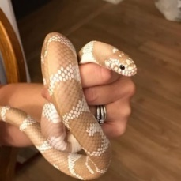

1. 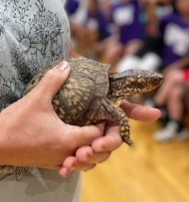***Reptile Encounters.*  Presented by Indian Run EEC. Join Dawn White, who brought us Birds of Prey/Hunters of the Sky last Fall, for a new exciting show. Bring the family out for a presentation with live native turtles and snakes. Learn their habits and features for survival. Guests can touch and examine the animals, as well as shells and sheds, and learn about the threats to these scaly critters, and how we can help protect them as important parts of our ecosystems. Saturday, September 13th, 2:00 pm – 3:00 pm.**

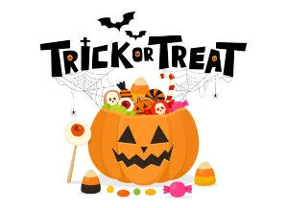**6) *Haunting for Candy at Union Meadows*. On Saturday, October 25th, 1:00-4:00 pm, (Rain Date: Sunday, October 26th). Bring the family out for our fun annual Boo Bash! Holiday trick-or-treat on the trail, pumpkin painting, and Blind Candy Taste Test Challenge, among other family friendly activities.**

**Meet your Parks & Recreation Board:**

Robert Erb-Chairman, Brenda Berriker-Vice Chairman, Kristen Keeler-Secretary,

William Woodruff-Member, Eric Woodworth-Member

*Additional details for events will be posted as they become available